***CONFIGURE Jenkins-Cucumber Plugin***

*Download Jenkins Cucumber Plugin (****cucumber-reports.hpi****)*

***INSTALL the Jenkins-Cucumber Plugin***

1. *Click the* ***Manage Jenkins*** *Link*

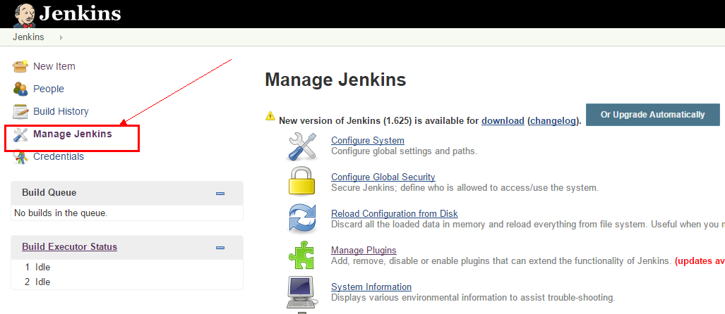

1. *Click* ***Manage Plugins***

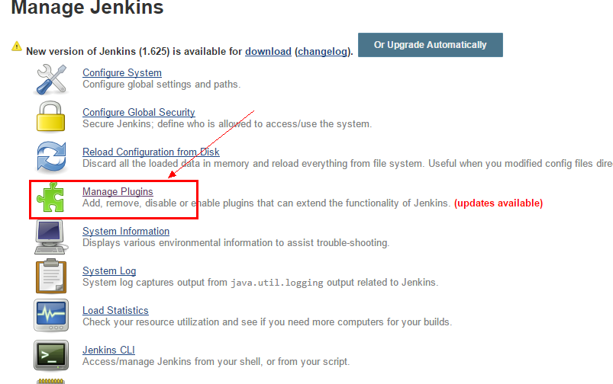

1. *Click* ***Advance Tab*** *on the* ***Manage Plugins*** *Page*

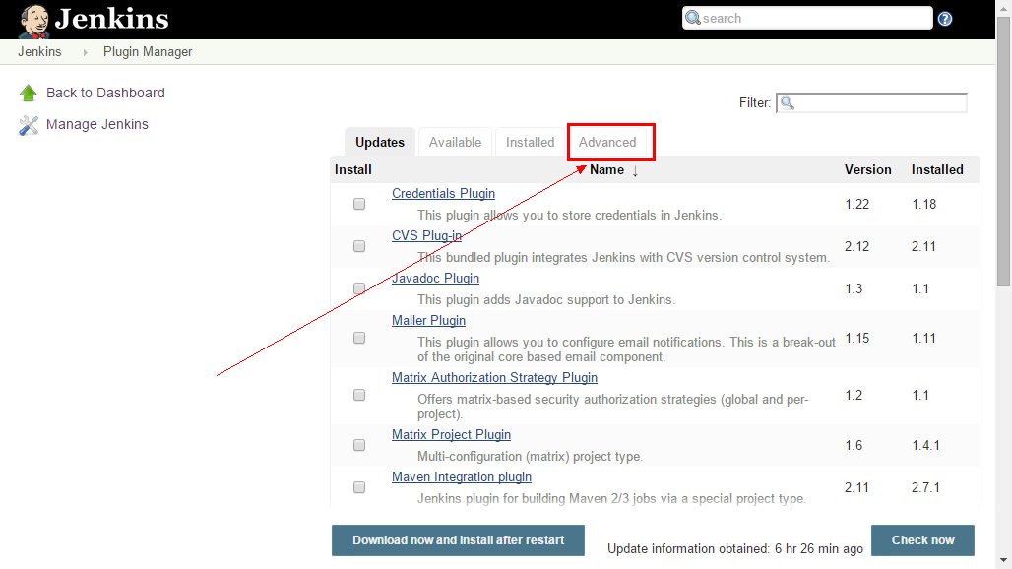

1. *Click* ***Choose File*** *and locate the* ***jenkins-cucumber.hpi*** *file, then click* ***Upload*** *button*

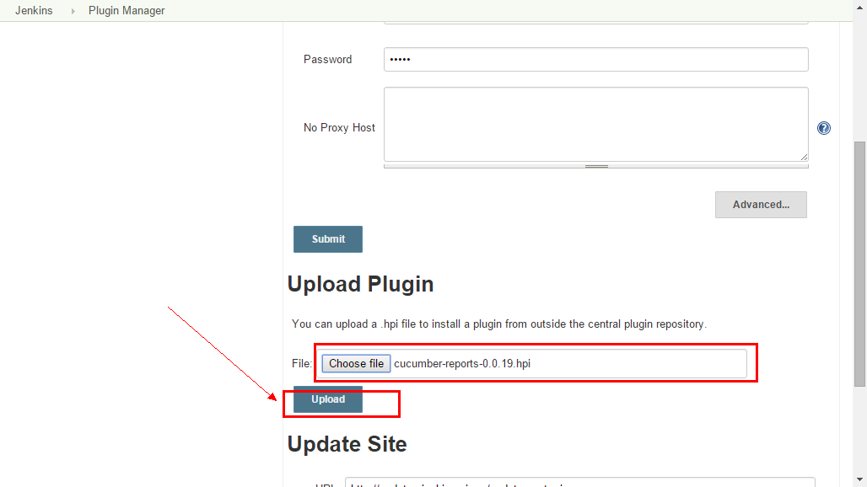

1. *Click the* ***Available Tab,*** *then click* ***Install without Restart***

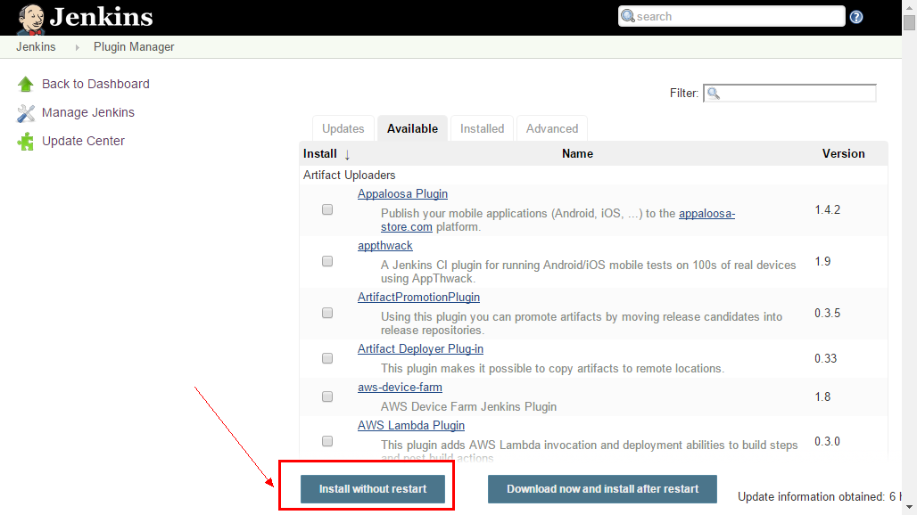

1. *Check the* ***Restart Jenkins when installation is complete and no jobs are running***

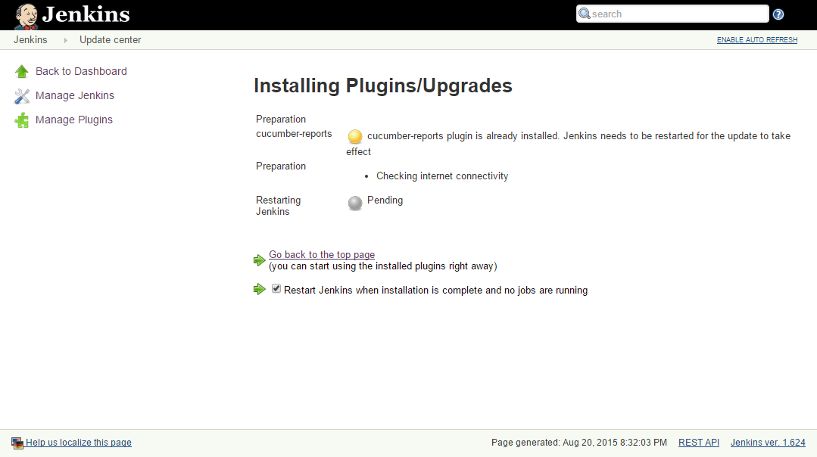

1. *After* ***Jenkins*** *restart go back to* ***Manage Plugins,*** *then click* ***Installed*** *Tab. Check* ***cucumber-reports*** *is installed and is ticked and the version is correct*

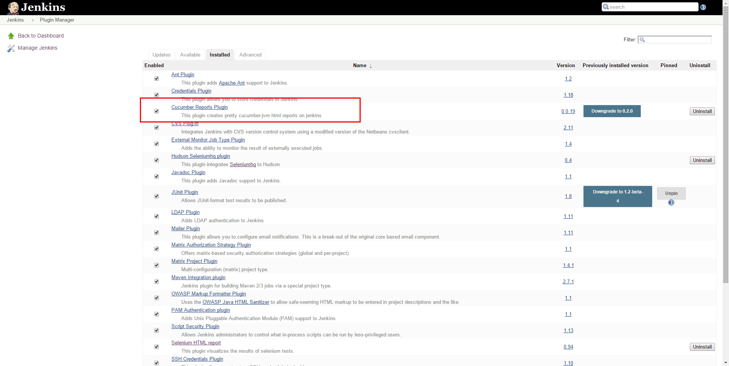

***PUBLISH Cucumber-jvm reports on Jenkins***

1. *Click the* ***New Item*** *Link*

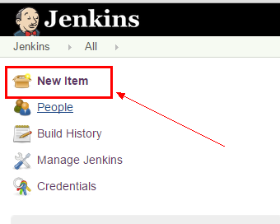

1. *Click* ***Freestyle Project*** *then press* ***Ok Button***

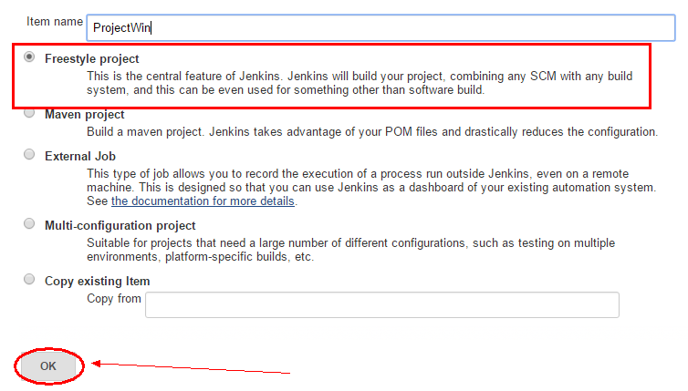

1. *Select”* ***Publish cucumber results as a report”*** *as* ***Post-build Actions***

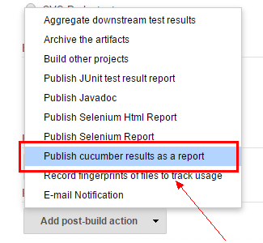

1. *Click* ***Advanced Button***

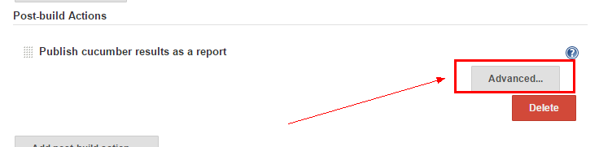

1. *Insert* ***JSON Reports Path*** *then click* ***Save Button***

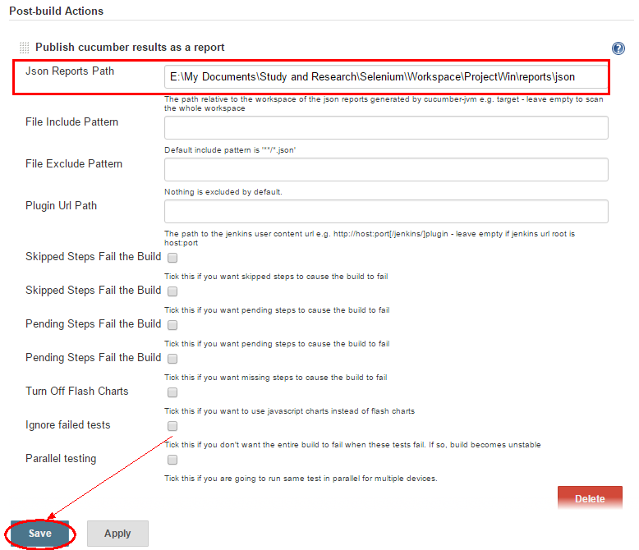

1. ***Sample Cucumber JVM-Jenkins Report***

